**Components**

**Create a new project using the command:**

ng new angular-app

**Move the code to the application folder and start the server**.

cd angular-app

ng serve

Open Visual Studio Code

Navigate to the created angular-app project folder.

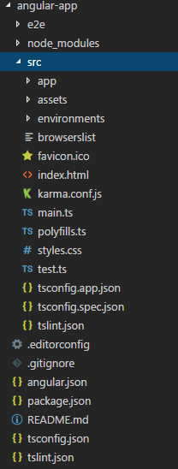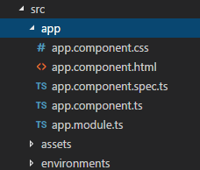

Add the following code in app.module.ts.

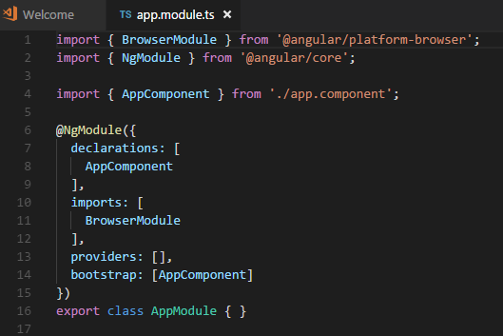

Create a folder called products inside the src/app folder.

Create a product-list.component.html file in the products folder.

Add the following code to product-list.component.html.

<h1> Product List Page </h1>

Create a file called product-list.component.ts.

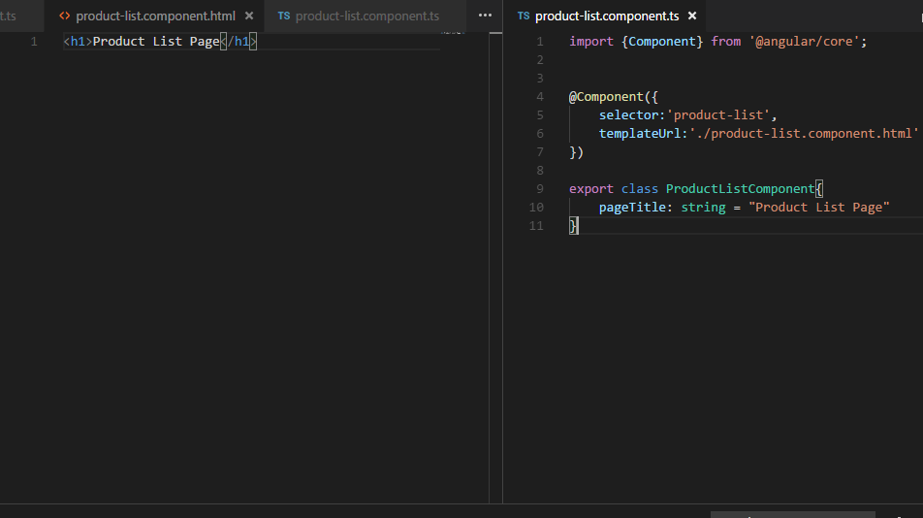

Add the following code in app.module.ts.

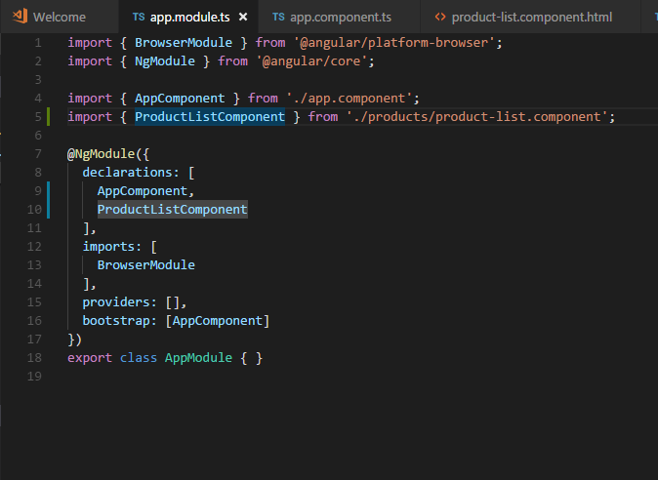

Add the following code in app.component.ts.

